**Tables Homework**

You may wish to print out this document to refer to as you carry out the exercises.

Please ensure that you have good control of your mouse – pivoting the base of your hand on the table – so that you have the fine control needed when adjusting and selecting.

(these exercises do NOT make use of the pre-styled table designs)

**Exercise 1: Specified Table 1**

Create the following table: 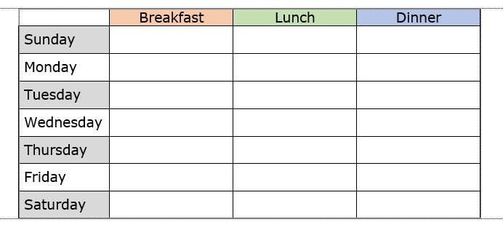

The finished table should have:

* Page orientation: portrait
* Page margins: narrow
* Meal columns: 3.5 cm exactly
* Day column: 3.3 cm exactly
* Day rows: 1cm each exactly
* Table centred
* Borders as shown
* Meal headings centred
* Day headings: left-justified, centred vertically.
* Heading cells selectively shaded, as suggested.
* Headings text: 14pt Verdana bold

.

**Exercise 2: Specified Table 2**

Create the following table:

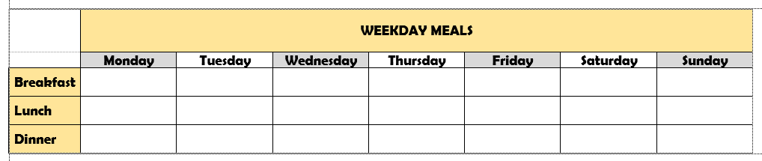

* Page orientation: landscape
* Page margins: narrow
* Day columns: 3.4 cm exactly
* Meal column: 2.5 cm exactly
* Day rows: 1cm each exactly
* Table centred
* Borders as shown
* Day headings centred
* Meal headings: left-justified, centred vertically.
* Heading cells selectively shaded, as suggested.
* Headings text: 14pt Berlin sans FB
* Overall table heading (within the table) as shown

**Exercise 3: User Table**

Create a table *that you have a use for*:

1. Decide its purpose
2. Decide how many rows and columns you need
3. Make the basic table
4. Put in the headers text
5. Set a font and size for the headers text (just using font and size, not Styles)
6. Align the headers text
7. Apply any cell shading that you want.
8. Apply the borders that you want.
9. Apply font and size to the empty cells (hint – you may want to enter some text of a likely length before deciding on the size)